**MARKING GUID OF BASICS ELECTRICITY**

**I SECTION A ANSWER ALL QUESTION**

Q1.a.Giga byte to Mega bytes/2Marks

1GB =1024 MB

b.100microfarad to farad

100micro farad=0.0001 farad

Q2.a.**Resistance The flow of electric current is subject to friction**. This friction, or opposition, is called

**resistance *R*** and is the property of a conductor that limits current./2marks

Q3 If a current of 10 A flows for four minutes, find the quantity of electricity transferred

/3marks

**Answer:**

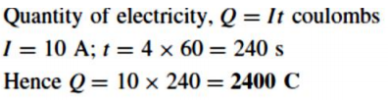

Q4 ,A 100 W electric light bulb is connected to a 250 V supply. Determine (a) the current flowing in the

bulb, and (b) the resistance of the bulb./3marks

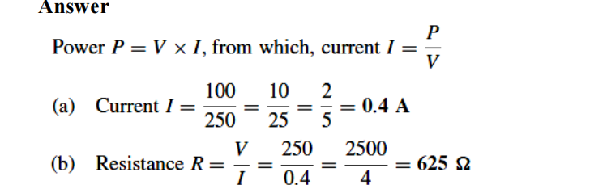

Q5.Determine the power dissipated by the element of an electric fire of resistance 20Ω when a current of

10 A flows through it. If the fire is on for 6 hours determine the energy used and the cost if 1 unit of

electricity costs 7p /6marks

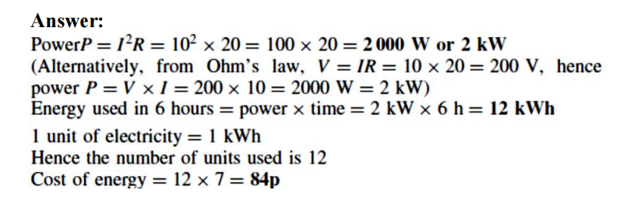

Q6.Ohm’s law states that “**the *current I flowing in a circuit is directly proportional to the applied voltage V and***

***inversely proportional to the resistance R, provided the temperature remains constant****.”*

**or V=IR or**

I: Current flowing in the circuit in Amperes (A)

R: resistance in ohms (Ω) and V: Voltage in Volts (V) /2marks

Q7a.**Conductance *(G)*** is the reciprocal of resistance. Whereas resistance of a conductor measures the

*opposition* which it offers to the flow of current, the conductance measures the inducement which it offers to

its flow.

Thus, conductance, in **Siemens(S)** is calculated by:/3marks



b.• **An insulator** is a material having a high resistance which does not allow electric current to flow in

it.

Examples: all plastics, rubber, glass, porcelain, air, paper, cork, mica, ceramics and certain oils./2marks

C.**A conductor** is a material having a low resistance which allows electric current to flow in it. All

metals are conductors.

Examples: copper, aluminum, brass, platinum, silver, gold and carbon. /2marks

Q8..A light bulb is rated at 100W for a 220 V supply. Find/9marks

(a) the resistance of the bulb

(b) the peak voltage of the source

(c) the rms current through the bulb.

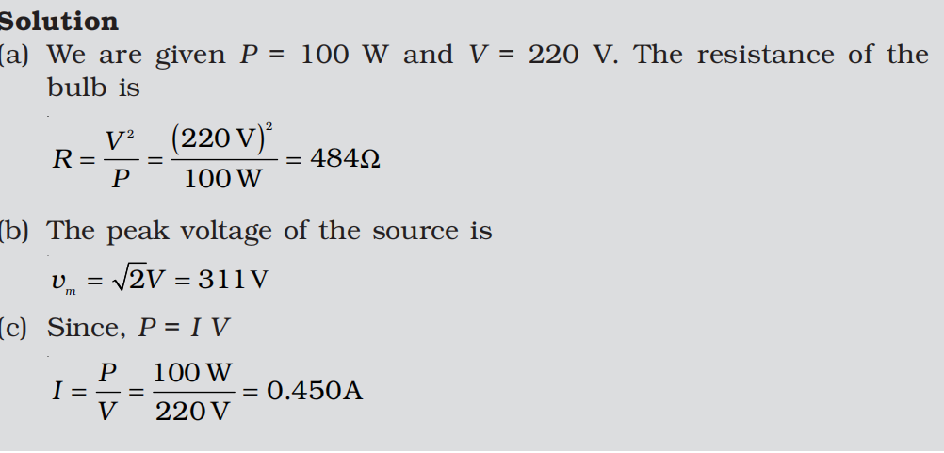

Q9.For the circuit shown in Figure below, find (a) the value of the supply voltage V and

(b) the value of totalcurrent**.**For the circuit shown in Figure below/9marks

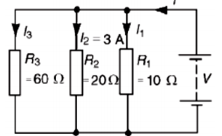

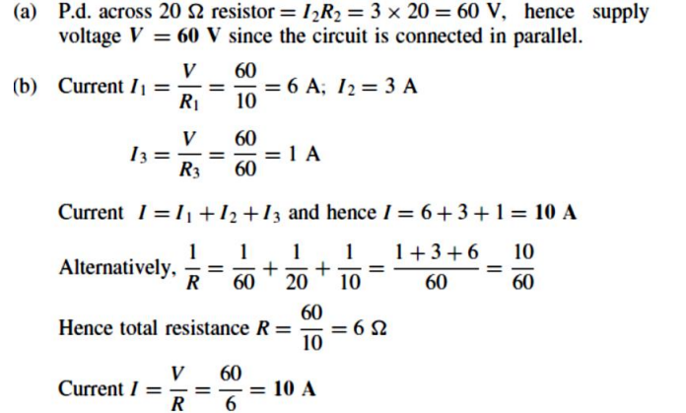

Q10.Find the equivalent inductance of the circuit given below./7marks

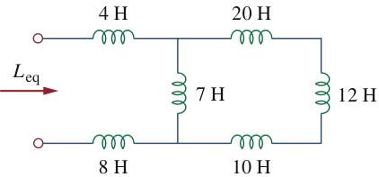

SOLUTION

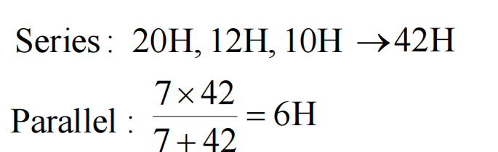

L=6H

**II SECTION B CHOOSE 3 QUESTION**

Q11.Calculate the equivalent inductance for the inductive ladder network given

in the circuit below/10 marks

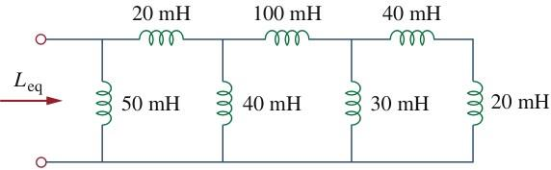

SOLUTION

* 40mH,20mH are connected in series

(40+20)mH=60mH, L=60mH

* 60mH ,30 mH are connected in parallel

1/L=(1/60 +1/30)

1/L=(1+2)/60

3L=60mH

L=20mH

* 20mH ,100mH are connected in series

20mH+100mH= 120mH

L=120mH

* 120mH, 40mH are connected in parellel

1/L=1/120+1/40=(1+3)/120

4L=120mH

L=30mH

* 20mH, 30mH connected in series

L=20mH+30mH

L=50mH

* 50mH ,50mH are connected in parellel

1/L=(1/50+1/50)

1/L=2/50

2L=50mH

L=25mH

Q12.Find the equivalent capacitance seen between terminals a and b of the

circuit in the figure below/10marks

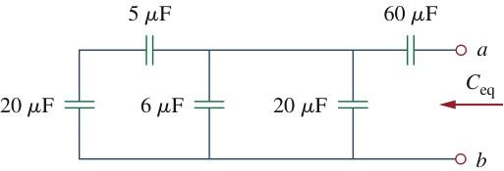

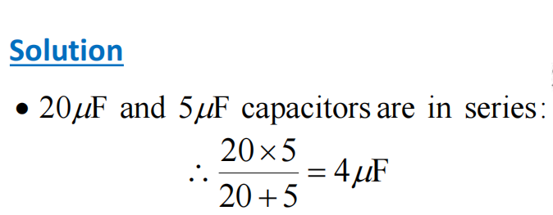

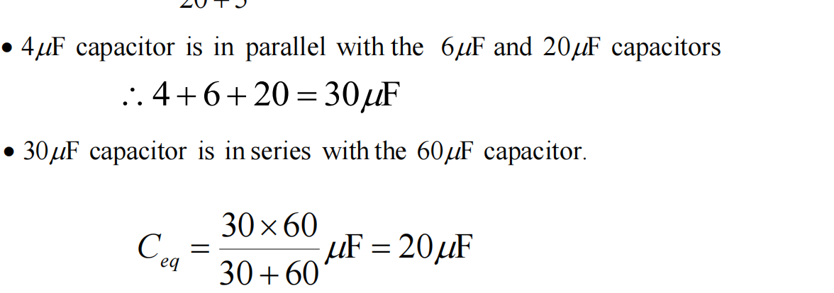

13Q. For the capacitors circuit below, determine the equivalent capacitance/5marks



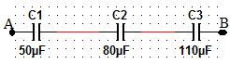

* C1, C2, C3 are connected in serises

Total capacitor : 1/C =1/C1+1/C2+1/C3

1/C=1/50+1/80+1/110

1/C=(8800+5500+4000)/440000

1/C=18300/440000

TOTAL CAPACITOR :CS=440000/18300

Ct= 24.043 micro farad

b./5marks

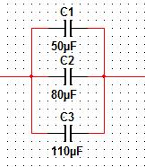

Total capacitor of C1 ,C2 ,C3

These capacitor are connected in parallel

Ct= C1+C2+C3

Ct= (50+80+110)microfarad

Ct=240microfarad

Q14.For the circuit shown in figure , determine (a) the battery voltage V (b) the total resistance of the circuit and (c) the values of resistors R1,R2 and R3, given that the p.d’s across R1, R2 and R3 are

5V, 2V and 6V respectively/10marks

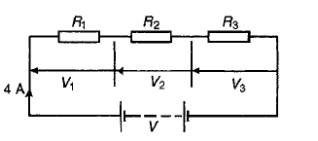

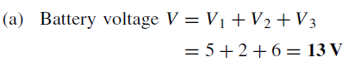

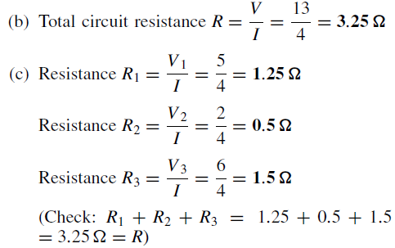

Q15.For the series-parallel arrangement shown in fig, find/10marks

(a) the supply current,

(b) the current flowing through each resistor

(c) the p.d. across each resior

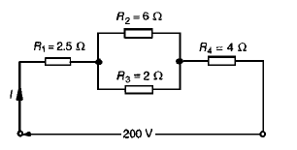

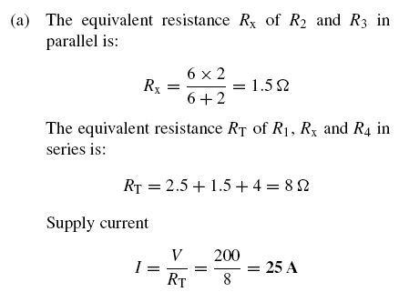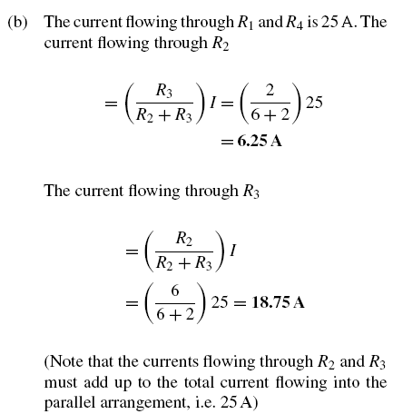

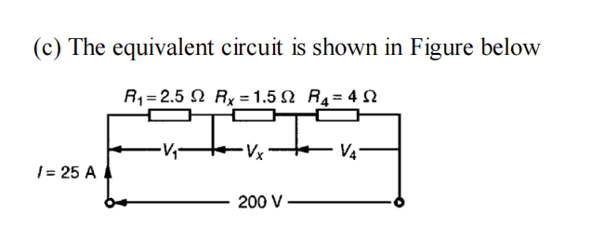

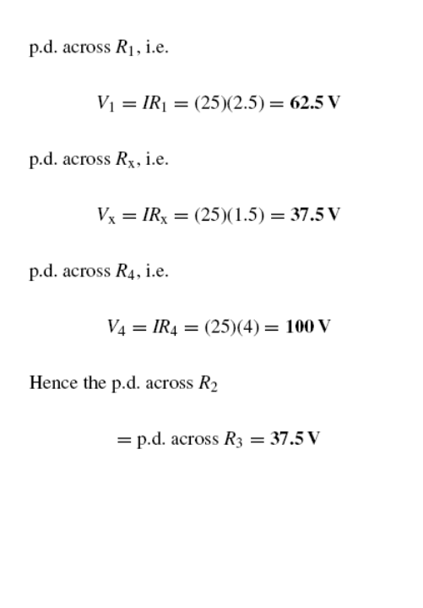

**III CHOOSE 1 QUESTION**

Q16.For the circuit shown in the figure, calculate (a) the value of resistor Rx such that the total power dissipated in the circuit is 2.5kW, (b) the current following in of four resistors/15marks

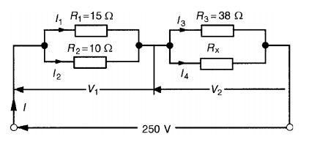

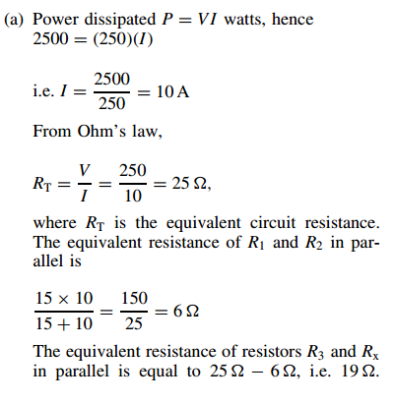

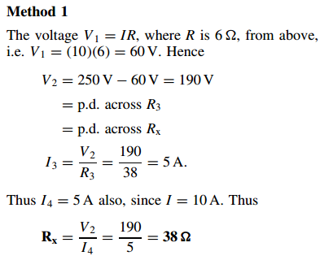

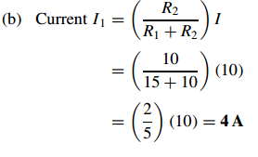

. Q17. for given voltage in terms of v(t) =220 sin 300t .find/15marks

1. frequency in hz
2. Periode in time
3. Maximum voltage

d . Amplitude

Solution

a . given that angular velocity ;w=300

w=2π. $F$

$frequency(F)=\frac{1}{T(period)}$**where f=frequency**

**T=period**

$F$ =w/2π =300/6.28=47.77hz /5marks

**B .T=period, T=1/ $F$**

T=1/47.77HZ =O.020 second/5marks

1. Maximum volotages is 200 volts/2.5marks

D.amplitude is 200/2.5marks